43.57: 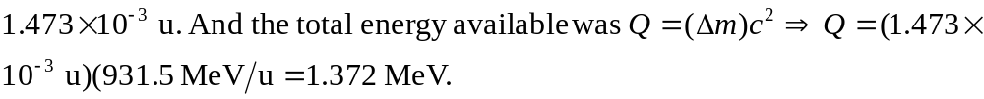
The emitted photon has energy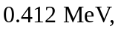so the emitted electron must have kinetic energy equal to

